CSA1509-Cloud computing and Big Data Analytics
Name : RS Vigneshwaran
Reg.no: 192521307
EXP 12 : Demonstrate virtualization by Installing Type-2 Hypervisor in your device, create and configure VM image with a Host Operating system (Either Windows/Linux).
Aim:
To demonstrate virtualization by installing Type-2 Hypervisor and to create and configure VM image with a Host Operating System .
Steps:
- Download VMware software and install it as Type-2 Hypervisor.
- Download Ubuntu or tiny os as ISO image file.
- In VMware workstation Create new VM
- Do the basic configuration.
  - Change number of processors or memory size etc , if needed.
  - If extra hard disk is needed , double click on hard disk addadditional hard disk.
- Created a virtual Machine.
- Launch the VM.
Implementation:
- Download and open VMware software.
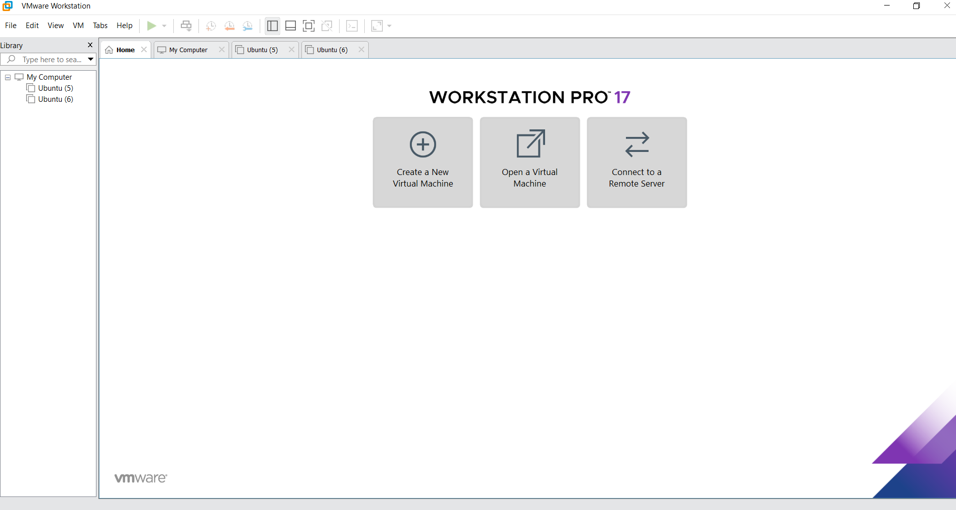
2.Create a new VM

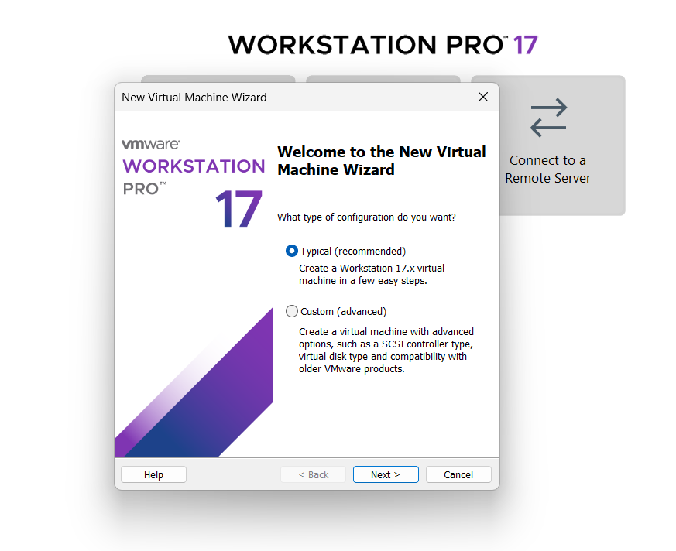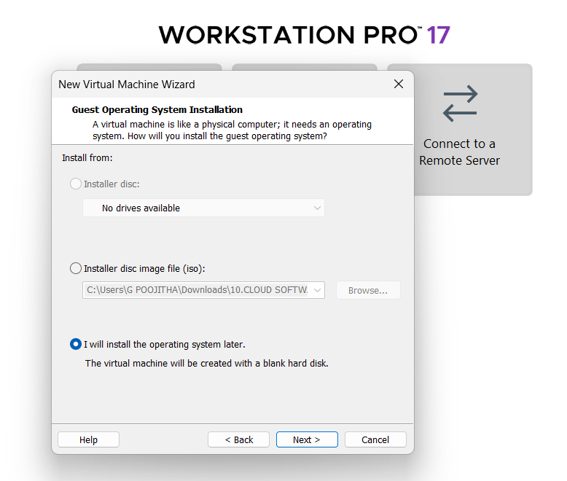
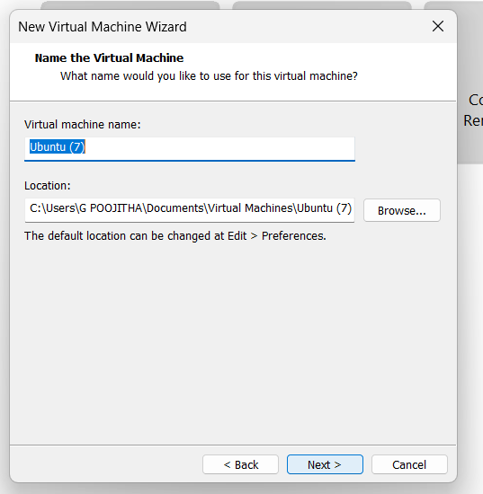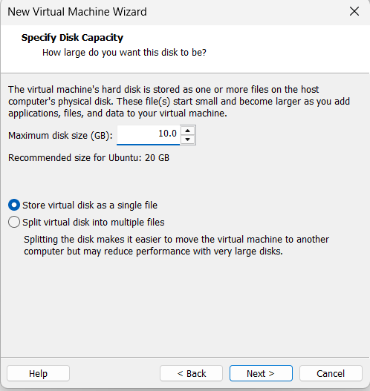
Name it anythingclick on nextAdjust the size of disk change the option to first and then click on next.
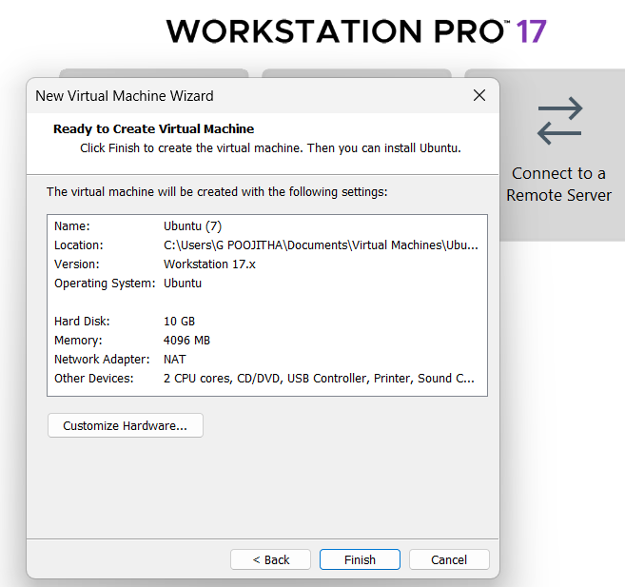 Click on Finish to Launch .
3.VM is created
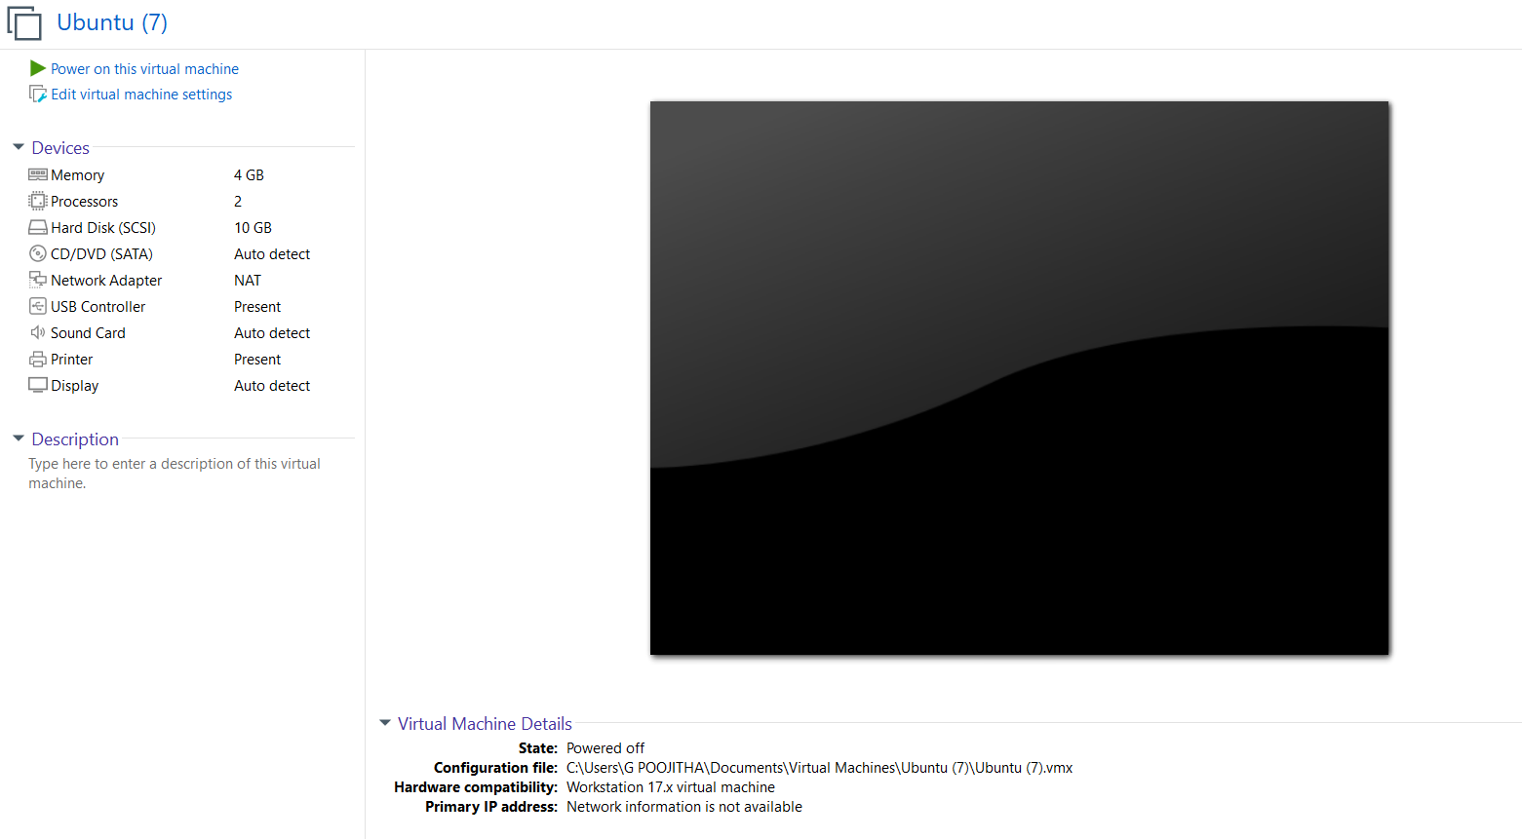
4. Double-click on each and Change the memory size , number of hard disks , number of processors if needed.
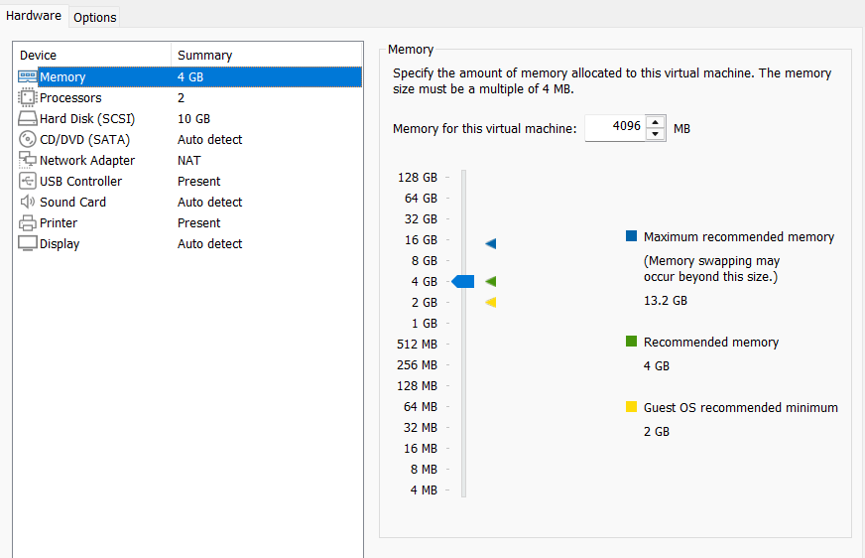

5. VM is created and configured.
